Food and Wine Onboard
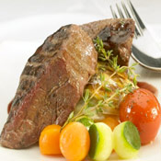 |  | 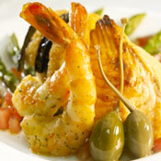 |  | 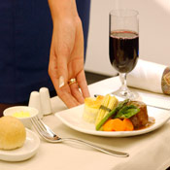

Dine with us
To offer our customers a fine dining experience, our menus are carefully designed to include the culinary delights from all the different countries we fly to. We are aware that presentation makes all the difference - our delicious meals are served on our elegant china and fine linen, designed exclusively for our premium cabins.
South African Airways is the first airline to be granted honorary membership of the South African Chefs' Association.
Our Selection
To offer our customers a wide selection to choose from we have a choice of 4 main courses in our premium cabins on all our international flights. Our tempting and tasty selection aims to satisfy the different palates from hearty to healthy.
So we invite you to enjoy our delectable starters, main courses, savory and sweet finales designed by a team of celebrity chefs. All our meals are complimented by the finest selection of South African wines.
Wine with us
Since 1986 SAA selects the finest South African wines to be served on board and in its lounges with the assistance of a panel of local and international independent judges. SAA’s annual wine judging is widely regarded as the most rigorous wine selection process in the country.
Wine and Dine in Comfort
South African Airways offers award-winning comfort in the air with 180° fully-flatbed seats in premium class, and seats in economy that offer more legroom than competitors with 34” of seat pitch. Every seat on board, whether in premium class or economy class, offers an individual on-demand entertainment system with blockbuster movies, television shows and music channels.

